**CHAPTER 4**

**EXPERIMENTAL RESULTS**

Cloud-based computing allows Internet-based resources, software, data and services to be provisioned on demand using a utility pricing model. Where solutions are architected for scalability, a cloud-based architecture can provide the ability to trade computation time against costs. This is readily applicable to applications that require frequent bursts of computational activity. Many individuals and businesses use cloud-based services for email, web searching, photo sharing and social networking. Scientists and engineers use a similar paradigm to make use of massive amounts of compute and data handling resources provided by companies such as Amazon, Microsoft and Google.

Central to a cloud-based architecture is the ability to purchase compute and storage resources using a flexible, on-demand billing model, much like the way traditional utilities (*e.g.* electricity) are purchased. This utility pricing model changes the way compute and storage can be exploited, encouraging scalable architectures and shifting the focus to almost unlimited, instant and on-demand resources with a direct monetary cost. Provisioning resources from a cloud provider is fast (typically taking times on the order of 1 min to 1 hour) and there is usually no minimum rental period, reducing or eliminating the need for large capital expenses as projects start-up or expand.

Cloud providers benefit from economies of scale, bulk purchasing hardware and electricity, and optimising machine administration. When combined with a flexible on-demand billing model, cloud providers can operate data centres very efficiently, in theory resulting in cost savings for end users. Owning and maintaining a data centre or cluster of machines is costly; hardware which is not being utilised is wasted (and probably wasting energy), so it is important to keep the hardware utilisation as high as possible to get best value from the hardware. Using cloud resources ensures that hardware utilisation is high, as unutilised resources can be returned to the provider (for use by others) and no longer incur a cost.

One of the key architecture patterns for cloud computing is to decouple a problem into independent discrete operations, and implement each with a worker. A worker consumes messages from a queue, completes the work stored in the message and then outputs a message to a different queue. Each message is a discrete piece of work which can result in data being created or consumed from storage (tables, SQL, blobs) the output message indicates work that has been completed and can easily become the input for another worker. This architecture is very flexible as workers can be reordered or substituted to achieve different objectives, or as a queue starts to get too long more workers of the same type can be created, speeding up the overall process.

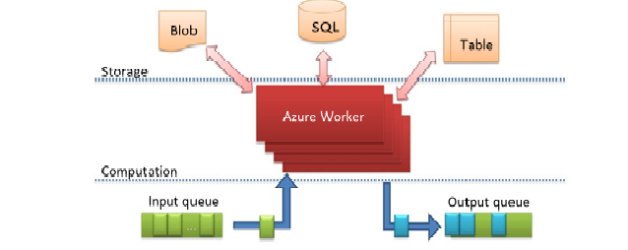

***Fig 4.1:*** *Windows Azure worker architecture pattern.*

**4.1 Data dissemination:** Cloud offerings are inherently global, highly available and have large bandwidth capabilities, making them ideal for data aggregation and dissemination. Often sharing data involves copying the data (perhaps multiple times) to ensure that the data and compute reside near each other but using a cloud-based resource, sharing can be as simple as changing access permissions. Once a dataset resides in a globally accessible cloud resource it too becomes a valuable resource suitable for third party data mashups. The data owner can provide access to a third party, who can purchase compute resources with the same cloud provider and immediately start processing the data set. The data owner is responsible for data storage costs but the third party is responsible for their own computational resource costs.

**4.2 Burst capability:** A data centre copes with predictable demand and unpredictable demand. When sizing a data centre for such a scenario it has to be able to cope with the peak load for the majority of the time this hardware remains unused. Where the data centre can cope with demand, the end user applications are unaffected. Once the demand exceeds the capability of the data centre, the under-resourced demand has a negative impact on the end user application. Moving such an application to a cloud provider ensures that you only incur costs for the resources utilised, whilst enabling rapid scaling to deal with a variable demand level.

Every object in the debris catalogue requires processing (e.g. for conjunction analysis) and as the catalogue grows, the demand for computational power increases. New launches increase the catalogue size in a predictable manner but conjunctions can unpredictably add thousands of new objects, then as the debris orbits decay, the number of entries reduces. A cloud-based architecture would facilitate the rapid procurement of processing power to process the debris orbital data and the characterisation of the conjunction event in a timely fashion. This is a fundamental component of the SST segment. As debris in the catalogue decays out of orbit, excess computational resources can be released, thus not incurring a cost. The burst capability of a cloud-based architecture offers rapid expansion and reduction of computational resources making it ideal for scenarios such as SSA.

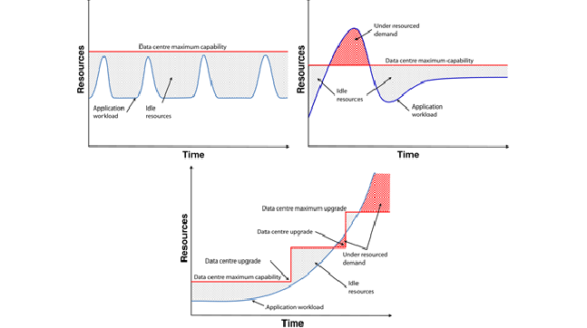

***Fig 4.2:*** *Available resource and demand curves for several data center scenarios*

**4.3 Super-Scalability:** The current debris catalogue size is limited by the ability to track distant or small objects. As detection methods improved the expect to track a wider range of debris. This will vastly increase the debris catalogue. Currently the catalogue contains approximately 20000 objects but there are millions of objects that could be tracked. This ability to purchase additional compute power in a flexible way means that a cloud-based infrastructure can be scaled to provide a continuity of awareness as the population of space objects and the SST measurement hardware evolve over time.